**Chapter 1**

**Introduction**

Software has become increasingly important in all face of the modern world as a result of technological advancements in recent decades, despite the complex software development process. The software development process has not yet been consistently effective and faces some issues, in contrast to many previous efforts to apply a variety of software engineering methodologies. These issues result in final product (software) rejection or failure, system and delivery time delays, abandonment of final products, and non-pass products. Even successful software projects that have been implemented in systems may require costly ongoing support or other software services, as well as a fine release.

The top flaws have posed significant difficulties and impressed the organization's bottom line on the software development process. This study tries to figure out how an organization's agile software development process can be improved to avoid the issues of inefficiency, time and money waste, and development process inefficiency. Agile methods, a software development process methodology that operates completely differently from traditional approaches, have recently been introduced.

This study reflects an in-depth analysis the factors affecting the Success in IT Project Management Methodologies. We will study on comparison between agile approaches Scrum/Kanban/Extreme Programming (XP) and the survey data analysis from Project manager with different branches/IT companies in India . The correlation depends on real ground level insight and the analysis will be based on current status or needing agile methodology after this long pandemic. The review be of this report (survey reports) will completely exploratory and rational on it's nature for this survey reports.

As there are many project management methods and approaches are available to choose for the new project but as of now ratio of the success is fully in favor of Agile methodologies. So we are analyzing the data on agile approaches. We are moving a head with the practical study and analyzing the data (Primary data) from experienced project managers of agile. Our main focus will be on Scrum and Kanban.

There will be an online tool which will be available for the project owners to analyze it properly before selecting the agile and what are challenges they are going face. As there is no solid solution or method when there is time for selecting the right methodology for project. As there are many factors which are needs to analyze and then project owner should choose, but when the client requirements are not well defined or say it could vary time to time, so client's feedback is necessary on daily or in alternate day basis then this agile is the best solution.

At here are we are trying to use AI (deep learning algorithm) to analysis the current data, which will provide help to project planner or project owner to decide what are the criteria and scenario, which could be the cause of the project success. By selecting the criteria and giving the respective value (in numerical digit) will help to get the close projection of project success.

In this chapter, background and brief information about well-known software development and production methodologies, as well as information about the agile methodology, are presented. In addition, the purpose of this study and the issues it will attempt to address are mentioned in this chapter. Following that, the research questions that serve as the foundation of this study were described, and the limitations associated with addressing these questions were discussed.Other concepts that will be discussed in this chapter include the significance of this study, the reason for selecting this field, the people who stand to benefit from it, the author's background, and the general structure of the work.

For the primary data we will use online survey google form to reach out our around 450 respondent (Project manager or project supervisor) from various IT companies to collect their experience with the same.

**Background**

**1. Knowledge about software development and methodologies**

A project's progression through a planned sequence of stages and a gate where a decision is made about whether to continue or stop is typical of traditional project management approaches. Stage-gate is a method for mapping out precisely what needs to be completed and how. In the stage-gate model, typical phases include defining the scope of the project, creating the solution, testing, and launching. The upfront planning and structured sequences of traditional project management methods have the potential to result in teams completing projects that miss the mark due to goals and requirements that changed somewhere along the development process. However, this model can be successful for seasoned project teams with a predictable development pathway.

Customary front-end strategies empower exhaustive arranging exercises with organized processes that permit advancement to happen in an effective and unsurprising way. However, project failure can be caused by a lack of effective management of the project's need for flexibility, excessive rework, customer dissatisfaction, and shifting technological requirements. Additionally, defining project requirements can be so time- and labour-intensive that technological requirements shift before the project even begins.

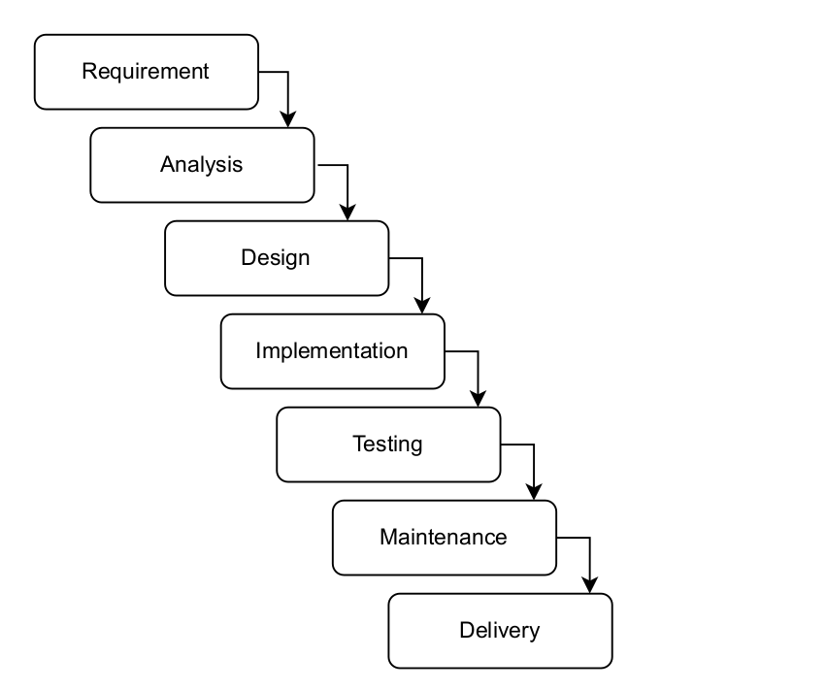 Traditional approach

**2. Knowledge about agile methodology**

The introduction of the agile project management methodology was prompted by the fact that traditional project management fails to adapt to the rapid changes in project requirements, which led to longer product life cycles and a longer time to market, as customers requested. The development process encountered increasingly dynamic projects in a competitive industry over time. These modifications posed challenges to the development process that needed to be taken into consideration.

The following are some additional software development issues: customers' desire for change, budget and timing issues, primarily related to customer involvement, and communication issues. The idea of agile methodology emerged as a response to these complexity to new circumstances. In this competitive and rapidly changing business environment, incorporating the agile method into the system development process is intended to assist the organization in becoming more productive in a shorter amount of time while avoiding additional costs.

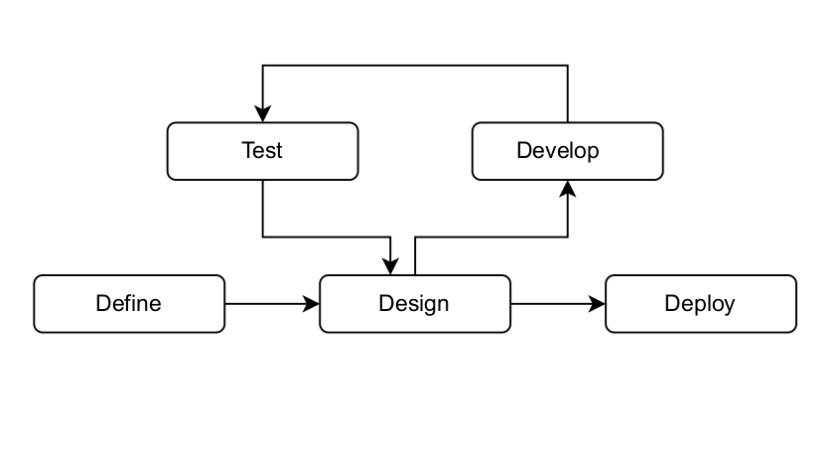 Agile Approach and Process

**3 Background knowledge about agile process and production**

Producing high-quality goods provides a competitive advantage in a market dominated by global competition. To deliver top notch items, flawed items killed through 100 percent screening. Defective agile methodology processes are reworked into more serviceable items for economic and environmental reasons. In reverse logistics, where used and secondhand products are reworked to increase the likelihood of money waste and environmental issues in all productions, agile process is also an important topic.

**4. Description of Research Problem**

Traditional software development tools can be utilized when project requirements are well-defined and consistent. When processes are well-structured, have systematic milestones, and follow a linear development approach, traditional project management methods, also known as "waterfall," are frequently used. With a focus on completing the project as a single, large-scale task, a team can work through the project in this manner. It can be challenging for a team to complete a large work scope on time, within budget, and to acceptable quality standards. To meet the need for flexibility and increased information flow, innovative and complex products of today necessitate new tools and techniques.

So far to make the project successful in agile methodologies we are in need to analyze the success factors which are categorized in following criteria:

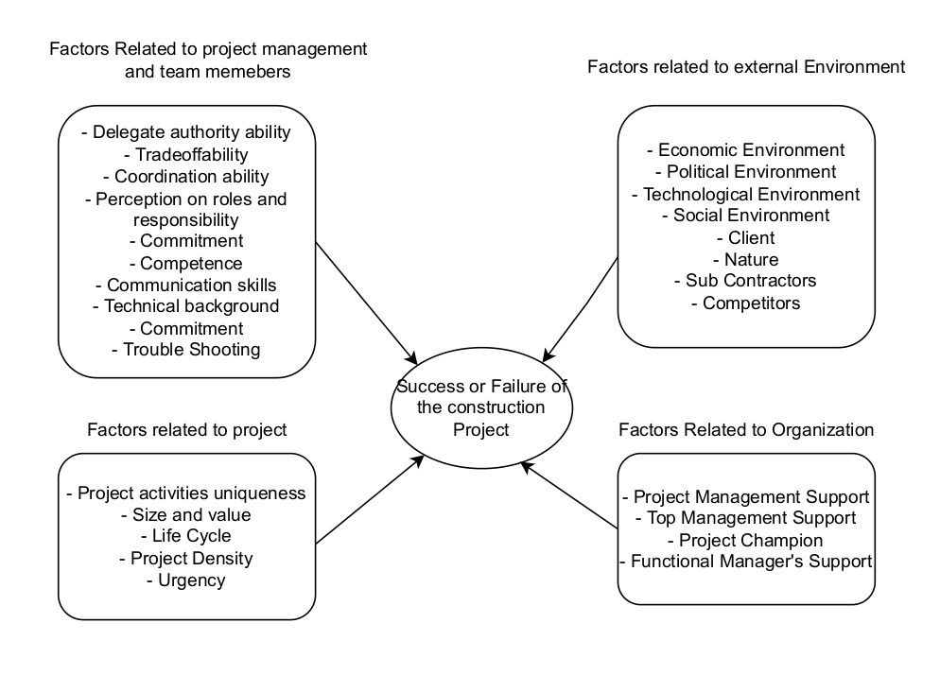

In 1996 Belassi and Tukel's designed the theory of success/failure factors

This study sought to identify and provide insight into agile methodology success factors that assist software development projects in completing the development process more successfully. Due to limitation and delimitation The software development process encompasses a wide range of tools, technologies, and techniques related to its improvement; however, the author of this study will concentrate solely on the application of agile methodology to the development process rather than covering all of its features.

Instead, the author will concentrate solely on a few specific aspects of limited subjects, which are referred to as success factors of agile methodology. Although the author has conducted extensive research on the system development process and agile methodologies, his or her primary focus has been on a small number of individuals, projects, organizations, processes, and technical subjects, such as time, cost, quality, and scope.

The Critical Success Factor is presented as a method for identifying names and assessing an organization's performance. The Critical Success Factor is defined as the small number of domains in which each individual, department, and organization will achieve success, especially in competitive performance. The key areas where everything needs to be done correctly through business processes are referred to as critical success factors. This is done so that manager goals can be met and accomplishments can flourish.

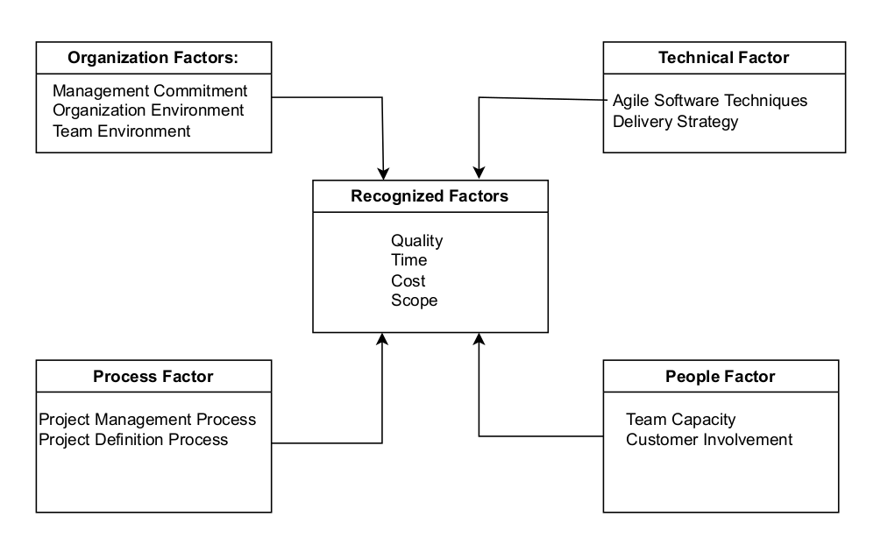

Critical Success Factors from four categories

**Chapter 2 (Literature Review)**

Fazal Qudus Khan, Saim Rasheed (2020) [1] significantly compared the Rapid Application Development (RAD) and Agile methods to develop the projects over the IT project management. They have conduct the Quantitative and Qualitative research for the same and have analyses it through Comparison, case study and by using the Sprints. but they have choose the student to complete their research work, so there are Biased data. T-test. F-test and Annova tests can be performed to have quality statistical analysis to evaluate the hypothesis. The sample size was too small for this research.

Abdallah Lalmi, Gabriela Fernandes and their team (2021) [2] have compared traditional, agile and lean methodologies. They have used qualitative method and have tried to develop the hybrid model from these three methods. Tried to reduce the manpower usage, shortening project schedules, reducing costs, eliminating waste and increasing project satisfaction and optimizing results. Their theory was based on the short project not suitable for the larger and big team. So, there are a lot of works are in need to work for.

Michael Pace (2019) [3] have tried to find out the discrepancy between the project management methodology and project success. He tried to conclude the result through the qualitative research to get the exact relationship between the Project management methodology and the chance for the success of the project. He did not used the survey methods, so his result was based on his comparison which is lack of reality. Such inductive inquiry emphasizes the efficient age of hypothesis by means of escalated interviews and topical examination of any arising designs.

Gurpreet Singh Matharu, Harmeet Singh and his team (2015) [4] Empirical Study of Agile Software Development Methodologies: A Comparative Analysis as well as quantitative analysis based on Secondary data (RE-SA-15th-Annual-State-Of-Agile-Report 2015). The review was exploratory and rational in nature, and utilized numerous contextual analyses as examination procedure. On this paper we provide the comparison analysis among agile various methodologies.  
  
Maureen Tanner(2014) [5] "Factors leading to the success and failure of agile project implemented in traditionally waterfall environment" Maureen has His study emerged from out of the literature, as sensible groupings of success and failure factors in agile project delivery: Culture, Customer Involvement and Mandate. A supposition that is made that achievement and disappointment factors are straightforwardly related as in progress factors incorporate the applicable and inverse disappointment figure many cases.

The Findings of RE-SA-15th-Annual-State-Of-Agile-Report (2020) [6], This year’s findings indicate significant growth in Agile adoption within software development teams, increasing from 37% in 2020 to 86% in 2021. Despite these challenges, obviously respondents keep on seeing the benefit of expanding Agile reception as a method for accomplishing basic business results. Truth be told, 2/3 of respondents recognized overseeing needs, imperceptibility, or arrangement among business and IT as seeing the most grounded positive effect from Agile reception. On the other hand, hierarchical culture — when routinely refereed to as a boundary to reception — is presently not a top test, with just somewhat multiple in 10 respondents distinguishing it as a boundary.

Enric Senabre Hidalgo in 2019, he has explored scrum in agile via quantitative analysis. He had sample of 17 sample size from his city. He had question deeply and had analyzed about the benefits of the scrum with his questionnaire and case study of their good projects. Enric was able to find out the list of benefits and it's result orientation help too much to deliver their project w.r.t. the requirements.

Peyman Badakhshan, Kieran Conboy and his team [2019] [5] had deep analysis about the use of scrum's key or potential positive influence use in other collaborative management and coordination in research process like in education department and other science department to reach their goal. They did survey in various universities and did their research via one to one interview and through online activities too.

Rahul Kumar, Kanwarpreet Singh and his team in (2019) [6] they did literature review and Pareto analysis in agile manufacturing from 1991 to to 2019. They Studied empirical studies and shortlisted for agile reliability and it's validity through the statistical methods with the Pareto analysis to find-out the factors which could make smoother and effective to implement the agile manufacturing in project managements.

In 2020 Mohsin Malik a , Shagufta Sarwar and his team [[7]] examine psychological empowerment in agile performance and practices. They did the survey what are the best practices are available to get the good performance of delivering the project via using the agile. through explanatory mechanism they were able to find-out the best relationship between the agile practices and it's performance on delivering the project smoothly.

Teguh Raharjo and Betty Purwandar [2020][[8]] they did SLR systematic Literature review over the 32 out 400 papers to get conclusion of the issue or challenges of implementing the agile as a project management for this they analysis the surveyed data from the Pulse of profession 2017. This surveyed data analysis shows the use of agile methodologies increased rapidly. Their main focus was with PMBOK which could extend to with other methods of agile via using the primary data.

Andrew Gemino, Blaize Horner Reich and his team on 2020 [9] did a regression analysis over the market with three methods: Agile, hybrid and with traditional methods. they found that 52% successfully delivered project were used hybrid methods. their analysis suggested that by achieving the same time, scope, result and quality hybrid and agile methods were significantly increased over the traditional methods. As their final outcomes indicates hybrid method is leading on their study for the project management.

Milos Jovanovic, Antoni-Lluis Mesquid and his team in 2020 [10] did a systematic analysis for factors and issues in agile adoption and transition. They analyze the development factors of agile which could be challenges for practitioner. They have analyzed 27 primary surveyed data and their factors at different level. They had evaluated the approaches which were varying institute wise as their project were seems to have different different requirements.

In 2020 Theo Thesing, Carsten Feldmann and his team [[11]] created a decision model for choosing the appropriate methods for a project in waterfall verses agile. They followed Adam (1996) who suggested the model which could use to take the decision between the waterfall and agile. He had interviewed 15 expert from various industries over the Germany. Their model check the criteria for cost, time, scope and project team. the findings were supported to hybrid model which were delivering the better result.

Elena Zavyalova, Dmitri Sokolov and her team in 2019 [12] surveyed through the telephone in St. Petersburg trough the consultancy services for different domain companies. their aim were to see how much HRM architecture factor involve in agile implementation in project management. through the survey they were able to find out it really depend on HRM architecture. they find out HRM related issues such as lack of soft skills of their employee, communication, inconsistency between responsibilities and inefficient of leadership styles.

Nikhil Govil, Mayank Saurakhia and his team in 2020 [13] did the study in behavior analysis of adopting the agile methodology and DevOps culture in eCommerce website. They have explored the use of DevOps in agile as both do have the iterative phases to implement in project management. They have explored it's benefits as well as their implementation methods which could be use to deliver it on efficient way.

In 2019 Javed Iqbal and Mazni Omar [14] has done online surveyed in Pakistan for 53 companies. They tried to find out the factors which could affect the Agile software team's evaluation process. They used the correlation technique to explain the ties between the productivity and team factors. they found the correlated factors which directly impacting the productivity are: inter team coordination , team empowerment, requirement workshop, test cases, stories and integration testings.

Rahul Kumar, Kanwarpreet Singh and his team in (2020) [15] did a empirical survey for priority of factors for implementing the agile manufacturing in manufacturing industries. They have analyzed the 17 barriers and used VIKOR method to analyze their surveyed data. They were analyzing the critical barriers to get the priority. They tried to get the attention of companies for these barriers which could causes the failure of the projects.

Mahboobeh Ramezani Farokhad, Jose Ramon Otegi-Olaso and his team on (2019) [16] had and assessment of success of innovation and research and development project life cycle model when they were creating a new product. They did project success evaluation and find out this evaluation is too important when choosing the methodologies among the others. They did survey and explored the ranking qualitative research why it is too important. At their finding they were elaborate their customer satisfaction has minimum contribution in project success.

Bogdan-Alexandru ANDREI, Andrei-Cosmin CASU-POP and his team (2019) [17] had briefly explored to determine the suitable methods for the project between the agile or waterfall. The design surveyed and focused on the methodologies (Scrum, Kanban and waterfall). At their finding there is no silver bullet which one is the best method as there are numerous factors which are supposed too accounted for and their finding shows there are strength and weakness of each methodology which could vary project to project.

Tsun Chow, Dac-Buu Cao in 2007 [18] did a survey on critical factors of success for a agile project management methodology using quantitative approach. They chosen quality, time, scope and cost for their parameter which is genuine but to perfect and leads for the further study. Team Capability, Delivery Strategy and Agile Software Engineering Techniques were the critical factors for the project success.

Shahbaz Ahmed Khan Ghayyur , Salman Ahmed and his team on 2018 [19] has briefly reviewed the systematic literature for the factors of barriers and success in agile project management methodology. Their studies includes motivator and demotivators of agile software development. Their comprehensive study detailed the role of motivator and demotivators factor on four classes: technical, process, people and in organization.

Raphael Kaim, Ralf-Christian Härting and his team in (2019) [20] had explored the transaction cost effect for the agile when Environment is increasing its complexity. Their focus was on scrum and have evaluated scrum fundamental which leads transnational cost effect for the same. Their approach was theoretical on which they explored transnational cost effect is more on the scrum than the traditional methodology.

Heimicke, Manuel and his team in 2019 [21] they correlated the agile methodologies in reference of mechatronic development. They have analyzed 19 factors with agile methodologies (Kanban, scrum, lean, SAFe, design thinking, TAF Model). Their qualitative approach for their studied explored how these factors evaluation help to choose the better one methodologies for their mechatronic project management.

Pedro Serrador, Jeffrey K. Pinto in (2015) [22] has studied does the agile works well they did quantitative study for the project success through the agile methodology. They used 1002 successfully delivered project from various industries and they have explored yes agile do have positive impact in project success ratio. Their Large-scale empirical and comprehensive analysis at various level shows great outcomes from the agile methodology.

In 2018 [23] Khaled Abdulnasser Alwaly and Nahg Abdulmajid Alaw has studied factors affecting the success in project management in constructions in Yemen via knowledge guide (PMBOK). They have created the questionnaire for their primary data from across the Yemen they had collected their data. They have evaluated the performance and quality for their project with using the knowledge guide PMBOK.

In 2021 Jayasaegaran Sithambaram and Mohd Hairul Nizam Bin Md Nasir [24] has done their study for success factor for the hybrid method of agile. For this they have done multiple interview survey with 42 sample size for 38 problems and challenges that have been simplified as factors, It is grouped into organizations, people, processes, and technologies. they chosen factors from process and people category.

Felipe Albuquerque, Alvair Silveira Torres and his team (2019) [25] have done their study the Lean agile methodology for the construction industries and their focus was on design phase only; For this have been chosen the 3 Brazilian industries. To get the proper and required outcomes they analyzed even in construction line industries are in need to have the agility on their business and they explored the way to reduce the errors, time consumption on phases, job responsibilities department wise and other factors, which are required to extend more on industries wise,

In 2018, Enric Senabre Hidalgo [26] has done a agile case study for adopting the agile in multidisciplinary Multidisciplinary project for their research. On their study they shown the contribution of the agile helps and smoothness of their process which leads to complete the project on time with using all available manpower with in time frame. For this they have analyzed the previous surveyed data too.

In 2016, Arturs Rasnacis and Solvita Berzisa [27] have done adoption and implementation study for the agile on their project management methodology. Giving prority to out of 20 methodologies from agile and it's types depend on the project type, employee and on the basis of the company. Their focus and their findings were employee characteristics, their relationship with other co-workers and motivation are main factors which could affect the success of their project. It was a case study evaluation which proposed the method includes the best practices from methodology adaption and change management by using the motivation and sociomatrics research methods.

In 2018, Gayathri K, M. Suresh [28] have done their study on MICMAC ranks to analyze the factors which have most affect the agile project management methodology. They have consider totally 12 factors and their interrelationship identification. They have used MICMAC to give priority at 5 level these factors. Their findings were employee behavior, their involvement, expertise on their domain and management natures are major factors among those.

Elvir M. Akhmetshin, Petr Yu. Romanov and his team did a study on 2019 [29] for The methodologies and theoretical methods have been used for the innovation project management in enterprise. They have used the PMBoK for their study which suitable for the target audience. They have used 9 section including (Integration, scope, time, cost, quality, human resource, communication, risk and procure-management). Which leads to better to use the PMBoK instead of traditional way.

Vikash Lalsing , Somveer Kishnah [2012] [30] have done their study on Human factor on agile project management methodology . They had considered the team member's experience, their intention and their behaviors while implementing the agile methods for their project. They have considered the psychological factors for their manpower too and for this they considered 3 agile teams and have analyzed their feedback.

Meghann L. and Drury-Grogan have done their study on (2014) [31] for success factors for agile team performance. Their major focus was on the objective's iteration and critical challenges that related to golden triangle of project management success. As their data was collected from 3 different companies which were using the agile, so this could limit the analyze the data which they gathered.

In 2019 Yasaman Arefazar and Ahad Nazari [32] have studied to use agile project management methodology as a tool for changing management in their construction business. They have created questionnaire for their best 60 business consultant in Iran. Their findings were to monitoring and improvements on manpower resource, time flexibility, client's participation, fluent communication and getting the requirements during the developments makes project successful.

Magne Jørgensen [2019] [33] he had a quantitative approach to get the relationship among the successful software development, agile practices and in project size. He has visited 3 seminars and have collected 196 responses from their respondent in Norway, His findings is showing that the agile project management leads to successfully project delivery beside the traditional methods, he have consider some of basic factors to analyze the data which could extend to get the precise result.

In 2018, Ruba Mohammad Haj Hamad and Mustafa Al Fayoumi has done their study [34] to convert WPMO (Waterfall project management office) to APMO (Agile project management office) via SATP (scalable Agile Transformation Process). Their study shown the importance of this conversion. Their focus on the training the manpower and explain its importance to get the successful outcomes.

In 2020, Krunal Bhavsar, Vrutik Shah [35] and his team studied and proposed a scrumbanfall which is combination of Kanban, scrum and waterfall model. It is something close or say it is a hybrid method which could lead and includes major factor to make the project successfully and it has great strength over the limitation of kanban and scrums. ML and AI could help more to analyze their data more precisely.

Saru Dhir, Deepak Kumar and his team in [2019] [36] have analyzed the success and failure factors for agile methodologies. They have focused on the factors accuracy, time, risk, quality and efficiency to their experimental team (grouped by 10 members). They took 5 projects as sample and outcomes was scrum was better than waterfall and spiral model. As their finding shown scrum do have better time, risk, quality and efficiency.

In 2020, Richa Sinha, Mohammad Shameem [37] and his team have done SWOT analysis on scaling agile methods over the overseas project development methods. They have selected 20 research articles for their study. Empirical validation, Prioritization and ranking analysis done on their respective factors and overcome with their generic method which could be implement in Agile development in overseas project development industries.

Muhamad Yusnorizam Ma’arif, Siti Mariam Shahar and his team in 2018 [38] have studied the challenges in implementing the scrum framework in software projects. There focus on factors like lack of knowledge of team members, lack of ownership, ineffective cost management on implementing the scrum on software development. Their objective was to implement the scrum on speed manner with quick delivery.

Carlos Tam a , Eduardo Jóia da Costa Moura and his team in (2020) [39] have analyzed the effect of factors in success of the agile project management. Their focus on human factors of the agile project success they have used the training and learning to manpower to get the impact of the human in agile approach. They have surveyed 216 professional of agile, and their finding the positive impact of human in agile implementation.

Randy Kurniawan, Dyah Budiastuti and his team on 2020 [40] they have analyzed the agile project management on balancing their firm performance. They chosen the telecommunication and technology provider in Indonesia. They surveyed 150 sample size from executive managers across the Indonesia. Their findings are showing the APM is directly impacting the firm performance, and it help to regular growth on completing the project within time line and with the expected cost.

In 2015, [41] Sergio Galvan, Manuel Mora, and their team discuss how typically businesses develop software, encounter multiple compliance and project-related issues while developing the project, and struggle to meet project deadlines. The scrum and XP are the foundations of their investigation, as are ISO/IEC 29110.There are still a number of expectations from their study that need to be fulfilled through in-depth research. Based on their study, which looked at small businesses that didn't exactly meet the requirements.

Fares AbuKhamis and Abdelhakim Abdelhadi analyzed the lean and agile methodologies for their study on Project Management Gaps in NGOs in 2022 [42]. Project managers, supervisors, and executives filled out the questionnaire for their online survey. According to their findings, approximately 36-40% of respondents were aware of lean and project management. This survey limitations stem from the fact that they used limited success factors, and their findings were positive regarding the success of agile/lean project methodologies.

In 2022 [43], Apivadee Piyatumrong and Panita Pongpaiboo from Thailand used the agile method to create a great IoT project management case study. They also tried to use software and hardware to apply the scrum framework and agile methodology to the Internet of Things. Which contributed to a greater number of advantages than the standard approach for the same. It was a case study in which 15 businesses were analyzed following the implementation of project management techniques.

Eldho Roshan Rajana and Vijayakumar Ambujakumari [44] conducted quantitative research on 404 companies to examine the factors that influenced them to use agile practice for project management. Their findings indicated that agile practice was the best option for meeting their client requirements, which they were unsure of at first but were able to meet thanks to the iterative model and modulation. They worked with the few factors that could be improved and could conduct additional in-depth research for them. Their focus was Scrum.

In 2020 [45] , Bekir ARLAK conducted a limited in-depth investigation into the use of agile methodology in project or process management for IT systems. In order to fulfill the requirements of the client, their primary focus was the application of the agile methodology to the IT infrastructure and process model. According to their analysis, the wrong approach to project management resulted in 74% of projects failing to meet the requirements of the client or exceeding budget and time.They choose to overcome these obstacles through Kaizen and lean practices.

Empirical research on the practices of Extreme Programming has been conducted by Sharifah Syed-Abdullah, Mike Holcombe, and their team [46] .Their objective was to determine how the XP method outperformed the conventional method in terms of project quality, time, and cost. There were a total of 96 students in various groups, all of whom contributed to the development of the project for the Institute's academic project submission. They looked at the data with only a few factors and found that project managers and supervisors might be better respondents than students.

In 2022 [47], American Ravi Kalluri managed risks using Agile scrum for complex projects in large corporations.Risk posed by human factors to complex scrum projects was one of his primary factors. His analysis was centered on the same's risk management and its comparison to conventional approaches. His investigation revealed a potential cause for the failure, as well as a possible course of action that the project's owner recommended. The negative team attitudes, job insecurity, and negative project retrospective all increase the risk of project failure, which is a major human factor. His study might succeed with the help of other factors.

In 2018 [48] , Kamila Takayama, Lyra, and their team conducted a small survey at the science degree (USP). For their fourth semester project, they grouped candidates with graduate and undergraduate students into four phases and experimented with combining the agile methodology with the scrum to improve project management skills. Their findings were positive at the institute level and unexpectedly successful. They came to the conclusion that adopting agile rather than any other conventional approach is always the best choice.

In 2020 [49] , Ilya Khomyakov, Ruzilya Mirgalimova, and their team used a questionnaire to conduct a survey with 122 businesses. Of those 122 businesses, 95 were very aware of the agile approach and were using it, while 27 were plan-based and used traditional methods. They looked back four years, from 2015 to 2019, and their data showed that even plan-based businesses were using some or all of the agile features and putting more into practice to close the agile gap. Their conclusion was that putting the agile approach into practice can be challenging and necessitates appropriate training.

In 2021 [50] , Lubna Siddique and Bassam A. Hussein conducted a brief survey of 21 software development businesses. After conducting interviews with all of these software management practitioners, they discovered that not all software companies prefer to work with the waterfall model, even for large and complex projects, when the requirements are precise. They came to the conclusion that employing a combination of the agile methodology and the waterfall model would provide a number of advantages over agile.

In 2004 [51] , Ernest Mnkandla and Barry Dwolatzky conducted a theoretical analysis of using agile instead of traditional software management companies in South Africa. This was done because the country has a lot of small companies and their employees range from 5 to 25 years old, making them unsuitable for agile as well. At any given time, two to three projects cannot be completed by them, so they only use traditional methods. The project's failure rate ranges from 65 to 80 percent using this waterfall strategy, which is excessive.

In 2020 [52] , Thomas Dilger, Christian Ploder, and their team conducted their research. Because of the COVID-19 pandemic, there was a labour shortage in Austria due to personnel relocation, and the government stepped in to fill the void. Austria planned for jobs with low budgets with the help of private sectors. Because it was bad for the IT and software industries to work with unskilled workers, they used agilefall, which is a mix of agile and waterfall. This really helped them get through these situations, and the results were great.

Samaneh Madanian, Maduka Subasinghage, and others [53] have investigated the impact of Scrum and XP from agile on the ERP implementation and development in addition to the CSF (Critical success factors) of Agile in ERP (Enterprise resource planning).The success of the project is led by resource management and the appropriate training of its employees, both in terms of time and money.

A study on PM CSF (critical success factors) was conducted in 2014 [54] by Zarina Alias, E.M.A. Zawawi, and their team. Therefore, they used five factors to determine whether CSF had an effect on project performance, and their findings showed that these factors had a 100% impact.Project Management Action (PMA), Project Procedures (PP), Human Factors (HF), External Issues (EI), and Project Related Factors (PRF) are their factors.

Mehtap Dursun, Nazli Goker, and their team [55] conducted a study of Success Factors in 2022 using the FCM (fuzzy cognitive map). According to their records, this was the only and best way to implement it on project management. They combined Agile, waterfall, and six sigma, resulting in good output. Their 15 research criteria were used for each of these methods for their case study. which still needs to have different outcomes in cases with the same methodologies in different cases.

In 2022 [56] , Janine Reiff and Dennis Schlegel conducted research on hybrid project management (HPM). Their goal was to demonstrate how agile's best features affect project management; however, given the scope of the project, agile is not only the most effective method for project management development. Their strategy for Scrum, waterfall, and the V models so far has been the hybrid method. Based on the requirements, scope, time, and budget, their literature review indicates that hybrid models could be more helpful than any specific model.

Innocent Musonda and Chioma Sylvia Okoro conducted a case study in 2022 [57] . Rather than focusing on technical skills, their research focused on the improvement of the industry's project management process. Business process re-engineering, or BPR, is the strategy that will lead to more successful projects. Due to the prevalence of covid-19, it was absolutely necessary to examine shifts, communication, virtual work, and standoff meetings; without them, project completion would be somewhat challenging to properly manage.

In 2022 [58] , Sayeed Salih, Samah Abdelsalam, and their team conducted a CSF (crucial success factors) analysis on the ERP (enterprise resource planning) systems used by small and medium-sized enterprises (SMEs) in South Africa. They used a structured questionnaire from 177 stockholders of two ERPs and used seven key factors. Their data was analysed using SPSS, and the results showed that their support for vendors was insignificant, resulting in the failure to implement project management in accordance with the requirements.

A survey was conducted by Michela Dall'Agnol, Alberto Sillitti, and their team [59] . They have examined 8000 projects and focused on the root cause of the failure. The top five main reasons for the projects' failure were poor communication with stockholders, customer involvement with developers, and an inexperienced project manager. Their conversation with 21 project managers about their issues and adopting agile.

For the RCE (Reengineering Cost Estimation) in 2019 [60] , Jaswinder Singh and Kanwalvir Singh conducted a brief study on CL (Chidamber and Kemerer) matrices. Through scrum and agile methodologies, they have utilized additional tools such as RMS (Rapid Minor Studio) for RES and IIBM (Rational Rose) for unified modeling. They used traditional methods to obtain precise cost estimates, which resulted in a loss for either the customer or the development team.They were somewhat close to getting a precise estimate, but there are still significant key factors that could lead to a more precise cost estimate for the same.

Hoda Ahmed Galal Elsayed and Tanzila Saba [61] conducted a brief investigation into the roles that 22 PM (Project management) tools play in both agile and traditional project environments. Their research was limited because it focused on tools, but its findings could be useful for the project's needs. Since requirements are changing based on the market and becoming increasingly difficult to implement, maintaining the project process in this day and age requires agile at this cost. However, tracking those requirements is becoming increasingly difficult, so they prefer to use tools for that purpose.

In 2018, C. J. Parada, M. P. Rojas Puentes, and their team [62] conducted a brief investigation into the utilization of Agile in software and project development in Columbia. Their study was based on 104 professional software engineers who participated in the survey. Their results were excellent—around 73% of respondents used agile, 43% scrum, and 19% XP/scrum hybrid methods in their projects. They analyzed the results using 11 characteristics, and the findings were in favor of agile in Columbia.

In 2022, Dr. Rupali Pravinkumar Pawar and Dr. Kirti Nilesh Mahajan [63] from Pune, India, conducted a small study to comprehend agile and traditional prince2 method success factors. For the same understanding, they used both the survey and the interview as primary data, as well as a book and articles as secondary data. The total number of respondents for the primary data was 42, ranging in age from less than three years to more than twelve years. There were a total of 12 factors examined for each, and they all came from product- and service-based businesses.

Élen Nara Carpim Besteiro, Jefferson de Souza Pinto, and their team conducted a study in 2015 [64] to determine the factors that contribute to PM success. Their factors were divided into four groups: control and monitoring, CSF (critical success factors), driver management, and CSF. For their findings, they used the questionnaire for 28 project managers. All out 57 factors with 18 for the board abilities, 19 for CSF and 13 for control and observing and 7 for the example learned. It was a good study, but the survey was small because only a few people took it. Once more people took it, it could be more accurate.

A study for the success factor analysis was conducted in 2020 [65] by Carlos Tam, Eduardo Jóia da Costa Moura, and their team. This study may have an impact on the ongoing project development. They conducted a survey with 216 respondents, and their most important factors were cost, time, and customer satisfaction. They conducted a brief comparison between agile-based and traditional project methodologies. Personal characteristics and social culture are influencing the software development life cycle (SDLC) either directly or indirectly, according to their findings.

In 2017 [66] , Aiman Khan Nazir, Iqra Zafar, and their team conducted a brief investigation into the impact of agile project management. Project management determines whether a project will be successful or unsuccessful based on five impact factors—procurement management, human resources, risk, time, scope, cost, and the stakeholder's perspective. choosing the agile methodology is preferable for accommodating changing project requirements.

The impact of scrum on project management was the subject of a study conducted by Faisal Hayat, Ammar Ur Rehman, and their team [67] . They conducted a brief survey; each respondent was aware of scrum and had implemented it. Their main factors were scope, time, and cost, all of which were properly managed with customer involvement and managed in a timely manner as requirements changed. They used Google Forms to select 21 companies and restricted their ability to obtain precise and detailed information from them.

A brief study on the use of agile in software project management (SPM) was conducted by Jay A. Dave [68] .The primary focus of his research was on the factors that prevent organizations from using agile project management. He used to compare it to traditional approaches, and he did a lot of research on why he didn't use agile or other approaches like hybrid ones. The scope of the project and its timing determine its success. If the requirements change during project development, the customer is responsible for paying for additional time and money.

A brief investigation into the roles and responsibilities of the manager in agile approach project management was carried out by Yogeshwar Shastri, Rashina Hoda, and their team [69]. Their study, which was based on 20 respondents from 18 organizations, demonstrates that there is still a need to study more about the same, as the agile main pillar self-organizing team, but still project manager is needed. However, the basic of agile states that there are no roles of project manager. Instead, there are roles of mentor, negotiator, process adopter, and project coordinator.

Vaishnavi Patil, Sanjana Panicker, and their team [70] conducted a brief study on the agile approach to mobile application development. They used Spotify as an example for their research because mobile applications have varying requirements and always require smaller and faster applications in comparison to software or web applications. Therefore, agile is crucial for mobile applications and must be implemented from beginning to end.

**Knowledge gap**

The high rate of failed and challenging IT projects that are over budget, behind schedule, and fail to meet stakeholder expectations has been the subject of numerous publications over the past few decades (Hartman and Ashrafi, 2002; 2002 Highsmith; 2006 Taylor; 2008 Standish Group; Pundak and others, 2011; Miller (2013According to Standish Group (2015), only 28.8% of projects achieved success between 2011 and 2015, 18.8% of projects failed, and 52.4% of projects were deemed challenging. When projects using agile methods are compared to those using waterfall methods, projects using agile methods are more successful (42 %) than projects using waterfall methods. According to Standish Group (2019), agile PMgmt methods also had a lower percentage of failed projects (8%) than waterfall PMgmt methods (21%) while agile PMgmt methods had a similar percentage of challenged projects (53%).

**Chapter 3**

**Rationale (Purpose of study and its use fullness)**

**3.1 AIM**: The primary aim of this study is to use deep learning to create a visual model of the essential success factors of agile implementation in Project Management. Based on the survey data, it will calculate the factors and display a graph showing how they affect the project.

**3.2 Objective**:

1. To ascertain the factors that contribute to successes.

2. What are the root causes and what we can do to avoid or minimize them?

3. How difficult is it for product owners to implement agile on their project?

4. How does human behavior affect the agile implementation?

5. How close these success factors will be to the agile project management process being implemented.

**3.3 Noteworthy Contribution**:

This study will demonstrate how Deep Learning Technology can be used to evaluate Agile implementation success factors for project management. The impact prediction graphs for these factors on IT projects will be displayed.

After considering additional factors, we can make this work live (online) for IT companies. It may be utilized at the corporate level. The experience of the project manager or supervisor will determine the impact of all of these factors; consequently, this will assist in selecting the appropriate methodologies and critical factors.

**Chapter 4**

**Research Methodology**

**1. Research Methodology:** We will use primary data to analyze the factors that influence IT Project Management Methodologies' success; through the questionnaire, qualitative and quantitative analysis. Sr. Management will benefit from the data analysis we provide. The project management process will be affected by a variety of factors, which management will investigate.

We will use three methods to collect data: semi-structured interviews, participant observation, and the collection of asynchronous communications take note that participant observation is our primary method for gathering data. Although the majority of Grounded Theory studies focus on interviews, we used interviews and online communications to support and elaborate on concepts primarily derived from participant observation.

**Sampling:** According to Bryman, A., & Bell, E. (2011), a non-probability sample is one that is used to conduct the survey by collecting data from individuals who serve as a representative of the organization or company. There are benefits and drawbacks to this sample data collection method. The fact that the people chosen for non-probability sampling are accurately representative is one of its drawbacks.

Non-probability sampling will become more valid and reliable if it includes accidental alternatives and covers as much of the population as possible. Even though a representative group of people who are familiar with agile methodology was chosen for this study and the sampling method was non-probability sampling, the study's validity can be established by the presence of a sufficient number of respondents.

**Hypothesis:** Team environment, team capability, the project management process and software engineering techniques are the independent variables in this study, while timing, quality, cost, and scope are the dependent variables. The following hypotheses are applied on the basis of these explanations: The null (Ho) and alternative (H1) hypotheses can be presented on the basis of this assumption.

**Hypothesis 1: For Organizational factor:**

1. Ho the existence of agile team environment is a success factor projects in terms of Quality

2. H1 the existence of agile team environment is a critical success factor inprojects in terms of Cost

**Hypothesis 2: For on People factor:**

1. Ho the existence of team capability is a critical success factor in terms of Timeless

2. H1 the existence of team capability is a critical success factor in terms of Cost

**Hypothesis 3: For Process factor:**

1. Ho the existence of agile project is a critical success factor in terms of Quality

2. H1 the existence of agile project is a critical success factor in terms of Cost

**Hypothesis 4: For Technical factor:**

1. Ho The existence of agile is a critical success factor in terms of Quality

2. H1 The existence of agile is a critical success factor in terms of Cost

**Hypothesis 5: For Project factor:**

1. Ho project dimensions is a critical success factor in terms of Scope

2. H1 project dimensions is a critical success factor in terms of cost

For Data Processing we will have five phases:

**Phase 1:** Data collection

The data collection part process refers to the entire process of gathering essential data and preparing them for analysis, as stated in the research objective.

**Phase 2:** Data Analysis

Testing, categorizing, rearranging, and sometimes comparing and combining the gathered data to produce new results are all parts of data analysis.

**Phase 3:** Implementation of Deep Learning Model

We will use deep learning classification models for predicting the impacts of the success factor in agile implementation in this phase.

**Phase 4:** Model Testing & Validation

During this phase our solution will be evaluated using training and testing data.

**Phase 5: Performance Testing**

During this phase, we will plot the accuracy and loss of our Deep Learning Model when it is applied to key factors that really need to be monitored when using the agile approach on any project.

**Chapter 5**

**Expected outcome of the proposed work**

We are sure that agile is the best methodology if the requirements change frequently; however, if the requirements change or we are building the product with precise and fixed requirements, we may use a hybrid approach.

However, in 80-85% of the cases, we do have requirements that may change over time, necessitating the use of agile, which may require additional time and resources.

A Deep Learning model for the prediction of will be developed in this study. Project managers will have access to a comprehensive online tool for analysis prior to selecting agile and determining the obstacles they will face. There is no solid solution or approach when it comes to selecting the project's methodology.

Our primary focus is on the major key factors that really need to be monitored. In order to successfully complete the project and satisfy the requirements of the customer, we will offer a graphical method for concentrating on the scenario.

1. Impact of the key factors of success in agile implementation.

2. A Deep Learning model for the prediction to monitoring the effect.

3. Why agile when traditional is easy to implements.

**Chapter 6**

**References**

[1] F. Qudus Khan, S. Rasheed, M. Alsheshtawi, T. Mohamed Ahmed, and S. Jan, “A Comparative Analysis of RAD and Agile Technique for Management of Computing Graduation Projects,” Comput. Mater. Contin., vol. 64, no. 2, pp. 777–796, 2020, doi: 10.32604/cmc.2020.010959.

[2] A. Lalmi, G. Fernandes, and S. B. Souad, “A conceptual hybrid project management model for construction projects,” Procedia Comput. Sci., vol. 181, pp. 921–930, 2021, doi: 10.1016/j.procs.2021.01.248.

[3] “A Correlational Study on Project Management Methodology and Project Success,” J. Eng. Proj. Prod. Manag., Jul. 2019, doi: 10.2478/jeppm-2019-0007.

[4] G. S. Matharu, A. Mishra, H. Singh, and P. Upadhyay, “Empirical Study of Agile Software Development Methodologies: A Comparative Analysis,” ACM SIGSOFT Softw. Eng. Notes, vol. 40, no. 1, pp. 1–6, Feb. 2015, doi: 10.1145/2693208.2693233.

[5] M. Tanner, “FACTORS LEADING TO THE SUCCESS AND FAILURE OF AGILE PROJECTS IMPLEMENTED IN TRADITIONALLY WATERFALL ENVIRONMENTS,” p. 9.

[6] “RE-SA-15th-Annual-State-Of-Agile-Report.pdf.”

[7] M. Malik, S. Sarwar, and S. Orr, “Agile practices and performance: Examining the role of psychological empowerment,” Int. J. Proj. Manag., vol. 39, no. 1, pp. 10–20, Jan. 2021, doi: 10.1016/j.ijproman.2020.09.002.

[8] T. Raharjo and B. Purwandari, “Agile Project Management Challenges and Mapping Solutions: A Systematic Literature Review,” in Proceedings of the 3rd International Conference on Software Engineering and Information Management, Sydney NSW Australia, Jan. 2020, pp. 123–129. doi: 10.1145/3378936.3378949.

[9] A. Gemino, B. Horner Reich, and P. M. Serrador, “Agile, Traditional, and Hybrid Approaches to Project Success: Is Hybrid a Poor Second Choice?,” Proj. Manag. J., vol. 52, no. 2, pp. 161–175, Apr. 2021, doi: 10.1177/8756972820973082.

[10] M. Jovanovic, A.-L. Mesquida, A. Mas, and R. Colomo-Palacios, “Agile Transition and Adoption Frameworks, Issues and Factors: A Systematic Mapping,” IEEE Access, vol. 8, pp. 15711–15735, 2020, doi: 10.1109/ACCESS.2020.2967839.

[11] T. Thesing, C. Feldmann, and M. Burchardt, “Agile versus Waterfall Project Management: Decision Model for Selecting the Appropriate Approach to a Project,” Procedia Comput. Sci., vol. 181, pp. 746–756, 2021, doi: 10.1016/j.procs.2021.01.227.

[12] E. Zavyalova, D. Sokolov, and A. Lisovskaya, “Agile vs traditional project management approaches: Comparing human resource management architectures,” Int. J. Organ. Anal., vol. 28, no. 5, pp. 1095–1112, Feb. 2020, doi: 10.1108/IJOA-08-2019-1857.

[13] N. Govil, M. Saurakhia, P. Agnihotri, S. Shukla, and S. Agarwal, “Analyzing the Behaviour of Applying Agile Methodologies & DevOps Culture in e-Commerce Web Application,” in 2020 4th International Conference on Trends in Electronics and Informatics (ICOEI)(48184), Tirunelveli, India, Jun. 2020, pp. 899–902. doi: 10.1109/ICOEI48184.2020.9142895.

[14] J. Iqbal, M. Omar, and A. Yasin, “An Empirical Analysis of the Effect of Agile Teams on Software Productivity,” in 2019 2nd International Conference on Computing, Mathematics and Engineering Technologies (iCoMET), Sukkur, Pakistan, Jan. 2019, pp. 1–8. doi: 10.1109/ICOMET.2019.8673413.

[15] R. Kumar, K. Singh, and S. K. Jain, “An empirical investigation and prioritization of barriers toward implementation of agile manufacturing in the manufacturing industry,” TQM J., vol. 33, no. 1, pp. 183–203, Dec. 2020, doi: 10.1108/TQM-04-2020-0073.

[16] M. R. Farokhad, J. R. Otegi-Olaso, L. S. Pinilla, N. T. Gandarias, and L. N. L. de Lacalle, “Assessing the Success of R&D Projects and Innovation Projects through Project Management Life Cycle,” in 2019 10th IEEE International Conference on Intelligent Data Acquisition and Advanced Computing Systems: Technology and Applications (IDAACS), Metz, France, Sep. 2019, pp. 1104–1110. doi: 10.1109/IDAACS.2019.8924298.

[17] B.-A. Andrei, A.-C. Casu-Pop, S.-C. Gheorghe, and C.-A. Boiangiu, “A STUDY ON USING WATERFALL AND AGILE METHODS IN SOFTWARE PROJECT MANAGEMENT,” J. Inf. Syst., p. 11.

[18] T. Chow and D.-B. Cao, “A survey study of critical success factors in agile software projects,” J. Syst. Softw., vol. 81, no. 6, pp. 961–971, Jun. 2008, doi: 10.1016/j.jss.2007.08.020.

[19] S. Ahmed, S. Ahmed, M. Ali, A. Naseem, A. Razzaq, and N. Ahmed, “A Systematic Literature Review of Success Factors and Barriers of Agile Software Development,” Int. J. Adv. Comput. Sci. Appl., vol. 9, no. 3, 2018, doi: 10.14569/IJACSA.2018.090339.

[20] R. Kaim, R.-C. Härting, and C. Reichstein, “Benefits of Agile Project Management in an Environment of Increasing Complexity—A Transaction Cost Analysis,” in Intelligent Decision Technologies 2019, vol. 143, I. Czarnowski, R. J. Howlett, and L. C. Jain, Eds. Singapore: Springer Singapore, 2019, pp. 195–204. doi: 10.1007/978-981-13-8303-8_17.

[21] J. Heimicke, M. Niever, V. Zimmermann, M. Klippert, F. Marthaler, and A. Albers, “Comparison of Existing Agile Approaches in the Context of Mechatronic System Development: Potentials and Limits in Implementation,” Proc. Des. Soc. Int. Conf. Eng. Des., vol. 1, no. 1, pp. 2199–2208, Jul. 2019, doi: 10.1017/dsi.2019.226.

[22] P. Serrador and J. K. Pinto, “Does Agile work? — A quantitative analysis of agile project success,” Int. J. Proj. Manag., vol. 33, no. 5, pp. 1040–1051, Jul. 2015, doi: 10.1016/j.ijproman.2015.01.006.

[23] K. A. Alwaly and N. A. Alawi, “Factors Affecting the Application of Project Management Knowledge Guide (PMBOK® GUIDE) in Construction Projects in Yemen,” p. 12.

[24] J. Sithambaram, M. H. N. B. M. Nasir, and R. Ahmad, “Issues and challenges impacting the successful management of agile-hybrid projects: A grounded theory approach,” Int. J. Proj. Manag., vol. 39, no. 5, pp. 474–495, Jul. 2021, doi: 10.1016/j.ijproman.2021.03.002.

[25] F. Albuquerque, A. S. Torres, and F. T. Berssaneti, “Lean product development and agile project management in the construction industry,” Rev. Gest., vol. 27, no. 2, pp. 135–151, Apr. 2020, doi: 10.1108/REGE-01-2019-0021.

[26] E. S. Hidalgo, “Management of a Multidisciplinary Research Project: A Case Study on Adopting Agile Methods,” p. 15.

[27] A. Rasnacis and S. Berzisa, “Method for Adaptation and Implementation of Agile Project Management Methodology,” Procedia Comput. Sci., vol. 104, pp. 43–50, 2017, doi: 10.1016/j.procs.2017.01.055.

[28] G. K and M. Suresh, “Modelling the factors of agile practices in project management A case of illumination project organization,” Int. J. Eng. Technol., vol. 7, no. 3.3, p. 541, Jun. 2018, doi: 10.14419/ijet.v7i2.33.14830.

[29] E. M. Akhmetshin, P. Y. Romanov, R. R. Zakieva, and A. E. Zhminko, “MODERN APPROACHES TO INNOVATIVE PROJECT MANAGEMENT IN ENTREPRENEURSHIP EDUCATION: A REVIEW OF METHODS AND APPLICATIONS IN EDUCATION,” vol. 22, p. 16, 2019.

[30] V. Lalsing, “People Factors in Agile Software Development and Project Management,” Int. J. Softw. Eng. Appl., vol. 3, no. 1, pp. 117–137, Jan. 2012, doi: 10.5121/ijsea.2012.3109.

[31] M. L. Drury-Grogan, “Performance on agile teams: Relating iteration objectives and critical decisions to project management success factors,” Inf. Softw. Technol., vol. 56, no. 5, pp. 506–515, May 2014, doi: 10.1016/j.infsof.2013.11.003.

[32] Y. Arefazar, A. Nazari, M. R. Hafezi, and S. A. H. Maghool, “Prioritizing agile project management strategies as a change management tool in construction projects,” Int. J. Constr. Manag., vol. 22, no. 4, pp. 678–689, Mar. 2022, doi: 10.1080/15623599.2019.1644757.

[33] M. Jorgensen, “Relationships Between Project Size, Agile Practices, and Successful Software Development: Results and Analysis,” IEEE Softw., vol. 36, no. 2, pp. 39–43, Mar. 2019, doi: 10.1109/MS.2018.2884863.

[34] R. M. Haj Hamad and M. Al Fayoumi, “Scalable Agile Transformation Process (SATP) to Convert Waterfall Project Management Office into Agile Project Management Office,” in 2018 International Arab Conference on Information Technology (ACIT), Werdanye, Lebanon, Nov. 2018, pp. 1–8. doi: 10.1109/ACIT.2018.8672701.

[35] Research Scholar, Computer Science & Engineering, Indus University, Ahmedabad, India., K. Bhavsar*, Dr. V. Shah, Research Guide, Computer Science & Engineering, Indus University, Ahmedabad, India., Dr. S. Gopalan, and Research Co-Guide, Business Administration & Management, Indus University, Ahmedabad, India., “Scrumbanfall: An Agile Integration of Scrum and Kanban with Waterfall in Software Engineering,” Int. J. Innov. Technol. Explor. Eng., vol. 9, no. 4, pp. 2075–2084, Feb. 2020, doi: 10.35940/ijitee.D1437.029420.

[36] S. Dhir, D. Kumar, and V. B. Singh, “Success and Failure Factors that Impact on Project Implementation Using Agile Software Development Methodology,” in Software Engineering, vol. 731, M. N. Hoda, N. Chauhan, S. M. K. Quadri, and P. R. Srivastava, Eds. Singapore: Springer Singapore, 2019, pp. 647–654. doi: 10.1007/978-981-10-8848-3_62.

[37] R. Sinha, M. Shameem, and C. Kumar, “SWOT: Strength, Weaknesses, Opportunities, and Threats for Scaling Agile Methods in Global Software Development,” in Proceedings of the 13th Innovations in Software Engineering Conference on Formerly known as India Software Engineering Conference, Jabalpur India, Feb. 2020, pp. 1–10. doi: 10.1145/3385032.3385037.

[38] M. Y. Ma’arif, “The Challenges of Implementing Agile Scrum in Information System’s Project,” Control Syst., vol. 10, p. 7, 2018.

[39] C. Tam, E. J. da C. Moura, T. Oliveira, and J. Varajão, “The factors influencing the success of on-going agile software development projects,” Int. J. Proj. Manag., vol. 38, no. 3, pp. 165–176, Apr. 2020, doi: 10.1016/j.ijproman.2020.02.001.

[40] R. Kurniawan, D. Budiastuti, M. Hamsal, and W. Kosasih, “The impact of balanced agile project management on firm performance: the mediating role of market orientation and strategic agility,” Rev. Int. Bus. Strategy, vol. 30, no. 4, pp. 457–490, Jul. 2020, doi: 10.1108/RIBS-03-2020-0022.

[41] S. Galvan, M. Mora, R. V. O’Connor, F. Acosta, and F. Alvarez, “A Compliance Analysis of Agile Methodologies with the ISO/IEC 29110 Project Management Process,” Procedia Computer Science, vol. 64, pp. 188–195, 2015, doi: 10.1016/j.procs.2015.08.480.

[42] F. AbuKhamis and A. Abdelhadi, “A Critical Analysis of Agile and Lean Methodology to Fulfill the Project Management Gaps in Nonprofit Organizations (NPOs).” Applied Sciences, vol. 12, no. 11, p. 5467, 2022, doi: 10.3390/app12115467.

[43] A. Piyatumrong and P. Pongpaibool, “Adapting Agile Approach for Managing a Learning Factory: A Case Study of an Industrial IoT Project,” papers.ssrn.com, Apr. 03, 2022. https://papers.ssrn.com/sol3/papers.cfm?abstract_id=4074030 (accessed Oct. 26, 2022).

[44] E. roshan Rajan and V. A. Santhosh, “Adoption of Agile Methodology for iMproving it project perforMAnce.” Serbian Journal of Management, Serbia, Nov. 12, 2021. doi: doi10.5937/sjm16-26854.

[45] B. Sarlak, “Agile Methodology for Project/Process Management IT System Infrastructure,” in 2020 11th International Conference on Computing, Communication and Networking Technologies (ICCCNT), Kharagpur, India, Jul. 2020, pp. 1–7. doi: 10.1109/ICCCNT49239.2020.9225593.

[46] S.-L. Syed-Abdullah, M. Holcombe, and M. Gheorghe. “Agile Methodology in Practice.” https://www.researchgate.net/publication/242427018. Jun. 11, 2014. https://www.researchgate.net/publication/242427018_Agile_Methodology_in_Practice.

[47] R. Kalluri. “A Human Factors Study of Risk Management of Complex Agile ..” www.researchgate.net. Aug. 01, 2022. https://ijbms.net/assets/files/1660410961.pdf .

[48] K. T. Lyra, M. L. Alves, F. H. C. Silva, K. Souza, and S. Isotani. “An agile project management experience | Proceedings of the XXXII ..” www.researchgate.net. Sep. 01, 2018. https://dl.acm.org/doi/abs/10.1145/3266237.3266248 .

[49] I. Khomyakov, R. Mirgalimova, and A. Sillitti. “An investigation of the project management approaches of agile and ..” http://www.agilemanifesto.org/. Apr. 03, 2020. https://dl.acm.org/doi/abs/10.1145/3341105.3374126.

[50] L. Siddique and B. A. Hussein, "Practical insight about choice of methodology in large complex software projects in Norway," 2014 IEEE International Technology Management Conference, 2014, pp. 1-4, doi: 10.1109/ITMC.2014.6918615.

[51] E. Mnkandla and B. Dwolatzky, “A Survey of Agile Methodologies.” Researchgate, South Africa, Dec. 01, 2004. [Online]. Available: https://www.researchgate.net/publication/234125993.

[52] T. Dilger, C. Ploder, W. Haas, and P. Schöttle. “Continuous Planning and Forecasting Framework (CPFF) for Agile ..” https://dl.acm.org/. Oct. 01, 2020. https://dl.acm.org/doi/10.1145/3368308.3415398 (accessed: Oct. 26, 2022).

[53] S. Madanian, M. Subasinghage, and S. C. Tachiona, “Critical Success Factors of Agile ERP Development and Implementation Projects: A Systematic Literature Review,” PACIS 2021 Proceedings, vol. 1, Jul. 2021, Accessed: Oct. 26, 2022. [Online]. Available: https://aisel.aisnet.org/pacis2021/211

[54] Z. Alias, E. M. A. Zawawi, K. Yusof, and N. M. Aris, “Determining Critical Success Factors of Project Management Practice: A Conceptual Framework,” Procedia - Social and Behavioral Sciences, vol. 153, pp. 61–69, Oct. 2014, doi: 10.1016/j.sbspro.2014.10.041.

[55] M. Dursun and N. Goker, “Evaluation of Project Management Methodologies Success Factors Using Fuzzy Cognitive Map Method: Waterfall, Agile, And Lean Six Sigma Cases,” International Journal of Intelligent Systems and Applications in Engineering, vol. 10, no. 1, pp. 35–43, Mar. 2022, doi: 10.18201/ijisae.2022.265.

[56] J. Reiff and D. Schlegel, “Hybrid project management – a systematic literature review,” International Journal of Information Systems and Project Management, vol. 10, no. 2, pp. 45–63, Jul. 2022, doi: 10.12821/ijispm100203.

[57] I. Musonda and C. S. Okoro, “A hermeneutic research on project management approaches applied in a business process re-engineering project,” www.emerald.com/, Jul. 12, 2020. https://www.emerald.com/insight/content/doi/10.1108/BPMJ-11-2021-0694/full/pdf (accessed Nov. 04, 2021).

[58] S. Salih et al., “Critical success factors for ERP systems’ post-implementations of SMEs in Saudi Arabia: a top management and vendors’ perspective,” IEEE Access, pp. 1–1, 2022, doi: 10.1109/access.2022.3202954.

[59] M. Dall’Agnol, A. Sillitti, and G. Succi, “Project Management and Agile Methodologies: A Survey,” Extreme Programming and Agile Processes in Software Engineering, pp. 223–226, 2004, doi: 10.1007/978-3-540-24853-8_28.

[60] J. Singh, K. Singh, and J. Singh, “Reengineering Cost Estimation using Scrum Agile Methodology,” www.semanticscholar.org, 2019. https://www.semanticscholar.org/paper/Reengineering-Cost-Estimation-using-Scrum-Agile-Singh-Singh/96d54becaa5abfaaede955dbb1aaf44cc27761aa#citing-papers (accessed Oct. 26, 2022).

[61] H. A. G. Elsayed and T. Saba, “Role of Agile Methodology in Project Management and Leading Management Tools,” https://www.researchgate.net/, Nov. 01, 2015. https://www.researchgate.net/publication/346429436_Role_of_Agile_Methodology_in_Project_Management_and_Leading_Management_Tools

[62] C. J. Parada, M. P. Rojas Puentes, and F. H. Vera-Rivera, “Study of the use of agile methodologies in the development of software construction projects in Colombia,” Journal of Physics: Conference Series, vol. 1126, p. 012056, Nov. 2018, doi: 10.1088/1742-6596/1126/1/012056.

[63] Dr. R. P. Pawar and Dr. K. N. Mahajan, “SUCCESS FACTORS FOR TRADITIONAL PRINCE2 METHODOLOGY AND AGILE IT PROJECT MANAGEMENT,” https://www.researchgate.net/, Aug. 16, 2022. https://www.researchgate.net/publication/362712820_SUCCESS_FACTORS_FOR_TRADITIONAL_PRINCE2_METHODOLOGY_AND_AGILE_IT_PROJECT_MANAGEMENT (accessed Jun. 01, 2022).

[64] É. N. C. Besteiro, J. de S. Pinto, and O. Novaski, “Society for Business and Management Dynamics Success Factors in Project Management,” www.semanticscholar.org, 2015. https://www.semanticscholar.org/paper/Society-for-Business-and-Management-Dynamics-in-Besteiro-Pinto/cbf9a76019e5899a6f1761a3a3bafb8725a87a77 (accessed Oct. 26, 2022).

[65] C. Tam, E. J. da C. Moura, T. Oliveira, and J. Varajão, “The factors influencing the success of on-going agile software development projects,” International Journal of Project Management, vol. 38, no. 3, pp. 165–176, Apr. 2020, doi: 10.1016/j.ijproman.2020.02.001.

[66] I. Zafar and A. Nazir, “The Impact of Agile Methodology ( DSDM ) on Software Project,” www.semanticscholar.org, 2018. https://www.semanticscholar.org/paper/The-Impact-of-Agile-Methodology-(-DSDM-)-on-Project-Zafar-Nazir/843733664dc56367e0c61a6a854a84b844798c45

[67] F. Hayat, A. U. Rehman, K. S. Arif, K. Wahab, and M. Abbas, “The Influence of Agile Methodology (Scrum) on Software Project Management,” IEEE Xplore, Jul. 01, 2019. https://ieeexplore.ieee.org/document/8935813

[68] J. Dave, “The Usage of The Agile Methodology For The Software Project Management Enabled Through Altering Fundamental Agile Practice,” https://www.researchgate.net, Jan. 01, 2015. https://www.researchgate.net/publication/280111238_The_Usage_of_The_Agile_Methodology_For_The_Software_Project_Management_Enabled_Through_Altering_Fundamental_Agile_Practice (accessed Aug. 12, 2014).

[69] Y. Shastri, R. Hoda, and R. Amor, “Understanding the Roles of the Manager in Agile Project Management,” Proceedings of the 10th Innovations in Software Engineering Conference on - ISEC ’17, 2017, doi: 10.1145/3021460.3021465.

[70] V. Patil, S. Panicker, and M. KV, “Use of Agile Methodology for Mobile Applications,” https://www.researchgate.net/, Nov. 16, 2016. https://www.researchgate.net/publication/310503566_Use_of_Agile_Methodology_for_Mobile_Applications (accessed May 10, 2016).

**Chapter 7**

**List of published papers of the candidate (During Ph.D.)**